
USN | 1 | M | S

(Autonomous Institute, Affiliated to VTU)
(Approved by AICTE, New Delhi & Govt. of Karnataka)
Accredited by NBA & NAAC with ‘A+’ Grade

SEMESTER END EXAMINATIONS – MAY 2022
Program | : | B.E. : Common to all Programs | Semester | : | I
Course Name | : | Basics of Civil Engineering and Mechanics | Max. Marks | : | 100
Course Code | : | CV14(O) | Duration | : | 3 Hrs

Instructions to the Candidates:
- Answer one full question from each unit.

 |  | UNIT- I
1. | a) | Explain the impact of infrastructural development on the economy and environment of a country. | CO1 | (10)
 | b) | Explain the components of Road in detail with neat sketch. Also, discuss properties and applications of RCC. | CO1 | (10)
2. | a) | List and explain different types of dams based on Material and Structural behaviour with neat sketches. | CO1 | (10)
 | b) | Discuss the Properties and applications of PCC and Structural Steel. | CO1 | (10)
 |  | UNIT – II
3. | a) | Explain briefly about “Principle of transmissibility of forces”. Also, Define a couple. Mention its characteristics. | CO2 | (10)
 | b) | Forces of 2N, 3N, 4N, 5N and 6N act at an angular point of regular hexagon towards the other angular points taken in order. Find the magnitude and direction of Resultant of given forces as shown in Fig 3(b).  6 N  5 N  4 N  3 N  2 N  Fig. 3(b) | CO2 | (10)
4. | a) | State and prove varignon’s theorem of moments. | CO2 | (08)
 | b) | Determine the magnitude, direction and position of the resultant of forces with respect to ‘O’ shown in Fig. 4(b).  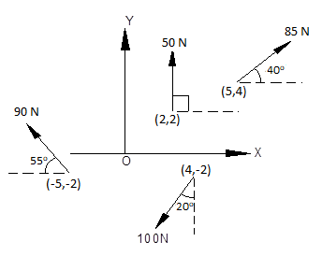  Fig. 4(b) | CO2 | (12)
 |  | UNIT – III
5. | a) | Distinguish between Resultant and Equilibrant. Also, write the conditions of equilibrium for Coplanar Concurrent and Non Concurrent force system. | CO3 | (10)
 | b) | Two identical rollers, each of weight 1000 N are supported by an inclined plane and a vertical wall as shown in Fig. 5(b). Find the reactions exerted by the wall and inclined plane at A, B, C and D.  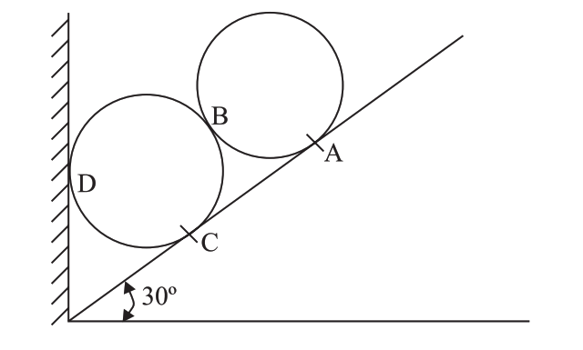  Fig. 5(b) | CO3 | (10)
6. | a) | List and explain different types of beams with neat sketches. Also, explain various types of loads that may act on beams with neat sketches. | CO3 | (10)
 | b) | Find the support reactions for the beam loaded as shown in Fig.6(b).  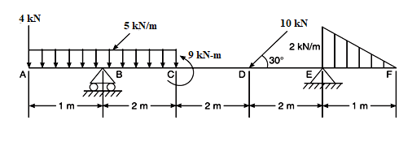  Fig. 6(b) | CO3 | (10)
 |  | UNIT – IV
7. | a) | Differentiate between Centroid and Centre of gravity. Derive the co-ordinates of Centroid of a semicircle from first principles. | CO4 | (10)
 | b) | Locate the Centroid of the shaded area as shown in Fig. 7(b). All dimensions are in mm.  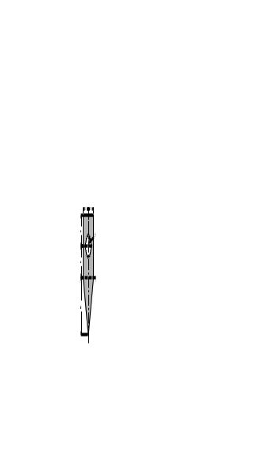  Fig. 7(b) | CO4 | (10)
8. | a) | State and prove theorems of moment of inertia. | CO4 | (10)
 | b) | Determine the moment of inertia and radii of gyration of the area shown in Fig. 8(b) about the base AB and the centroidal axis parallel to AB.  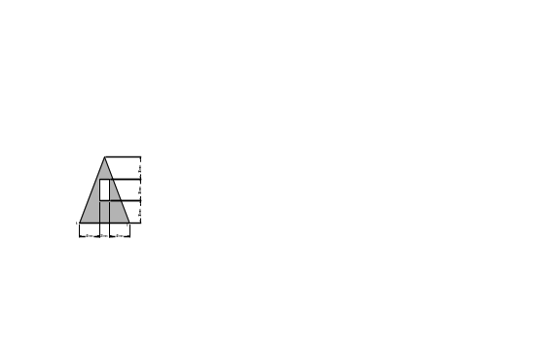  Fig. 8(b) | CO4 | (10)
 |  | UNIT – V
9. | a) | Define the following terms:  (i) Dry friction (ii) Coefficient of friction (iii) Limiting friction (iv) Angle of friction (v) Cone of friction. | CO5 | (10)
 | b) | What is the minimum value of force P to cause impending motion rightwards for the block 200 N shown in Fig. 9(b). Assume coefficient of friction μ=0.25 for all contact surfaces.  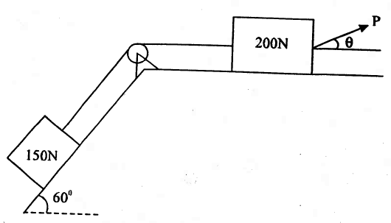  Fig. 9(b) | CO5 | (10)
10. | a) | Define the following terms :  (i) Displacement (ii) Velocity (iii) Curvilinear motion (iv) Rectilinear Motion (v) Projectile. | CO5 | (10)
 | b) | A projectile is fired with an initial velocity of 50 m/sec at an angle of 40⁰ with the horizontal. Determine:  - The horizontal range  - Maximum height attained by the projectile  - The time of flight. | CO5 | (10)

****************

